MEDIA & PRESS KIT

DR. NAEEM MEO
American Author • Retired Physician • International Thriller Writer
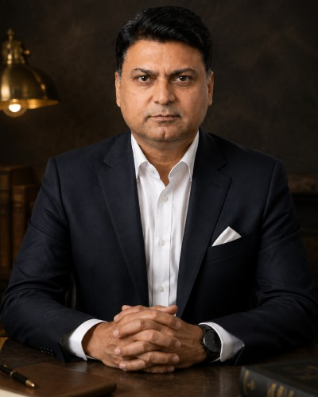

WHERE FICTION CHALLENGES POWER.
QUESTION EVERYTHING. • TRUST NO ONE. • FOLLOW THE EVIDENCE.

DR. NAEEM MEO • MEDIA & PRESS KIT 1

AUTHOR

Cinematic thrillers shaped by medicine, systems and global affairs.
Dr. Naeem Meo is an American author and retired physician whose fiction explores power, politics, intelligence, medicine, technology and the human condition. Drawing on more than three decades in healthcare, he writes international thrillers blending suspense, medical realism, cyber warfare, espionage, political intrigue and conspiracy.
His fictional universe examines governments, intelligence agencies, healthcare systems, corporations, organized crime and emerging technologies through stories about authority, ambition, justice, deception, resilience and accountability.
“What happens when power exists without accountability?”
The source material identifies 16 books and counting, while the supplied document contains 15 identifiable book covers. This edition includes every supplied cover and keeps each description matched to its own title.

DR. NAEEM MEO • MEDIA & PRESS KIT 2

DARK POWER SERIES

Power, conspiracy, supernatural mystery and science fiction.

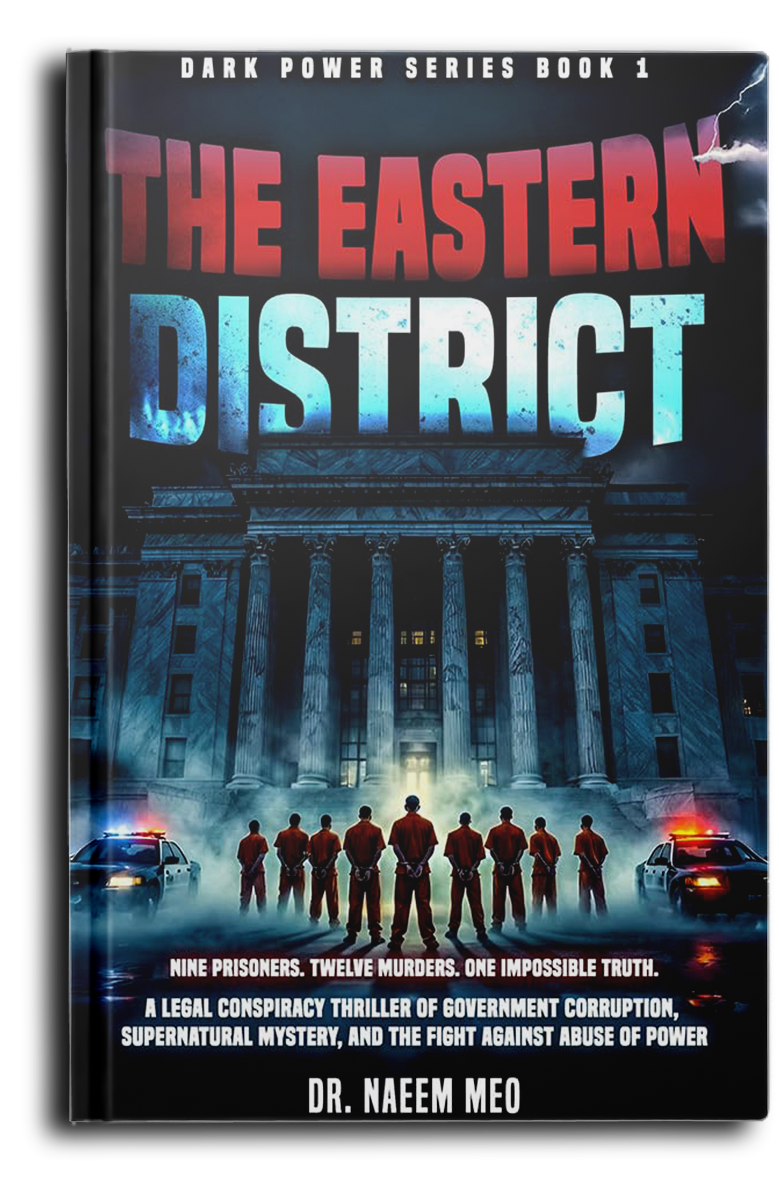
The Eastern District
Twelve influential officials are found dead under identical, impossible circumstances, leading investigators toward a controversial case involving justice, corruption and alleged supernatural forces.
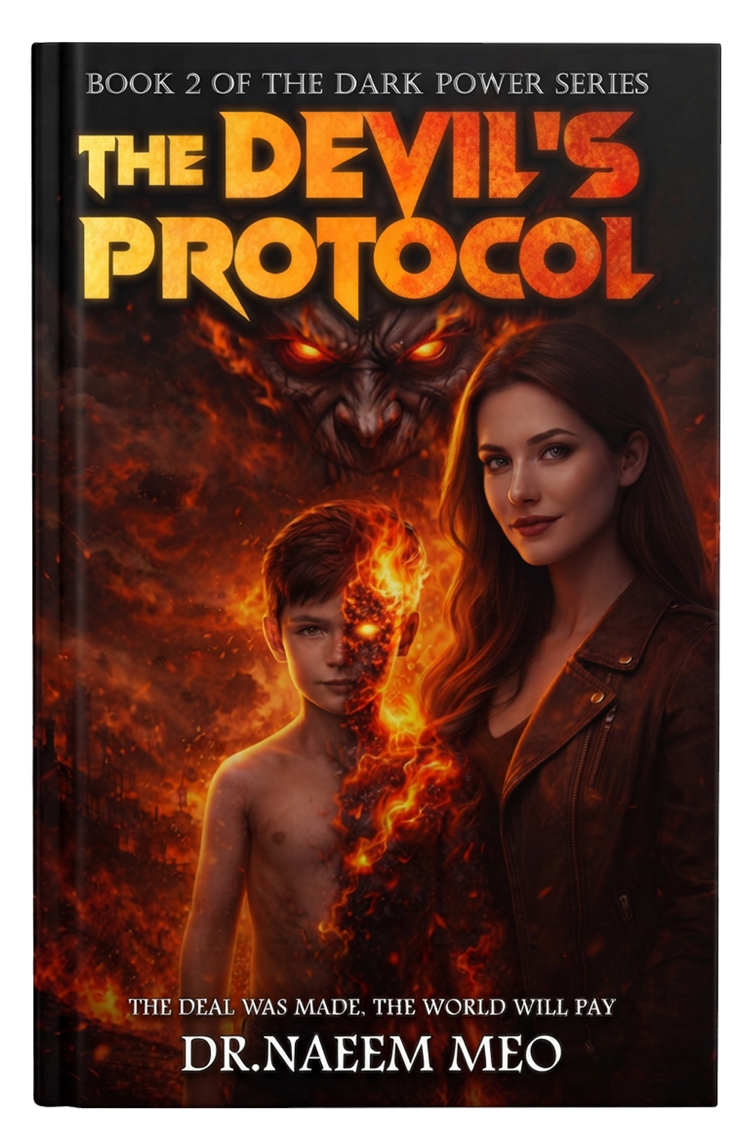
The Devil’s Protocol
A supernatural thriller about sacrifice, a dangerous agreement, an ancient force and a race to uncover a plan that could affect the balance between humanity and the supernatural.

DR. NAEEM MEO • MEDIA & PRESS KIT 3

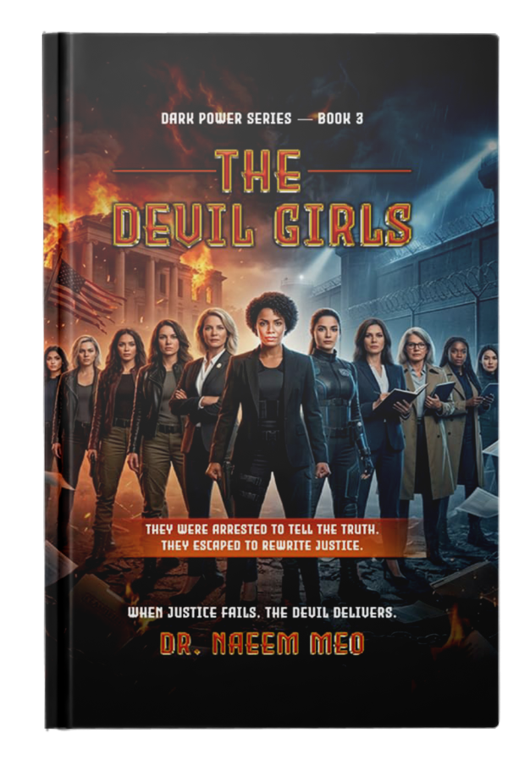
The Devil Girls
Eleven women enter a trial to expose hidden operations, political manipulation and global power games—before the trial is shut down and the women escape.
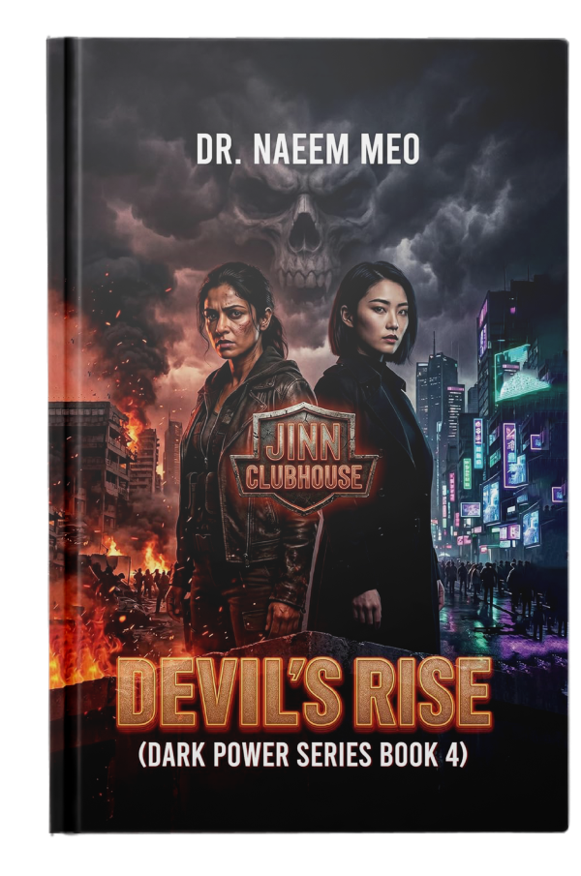
Devil’s Rise
A justice-driven international thriller that expands from corruption in India into the global JINN Network, geopolitical conflict and a supernatural power struggle.

DR. NAEEM MEO • MEDIA & PRESS KIT 4

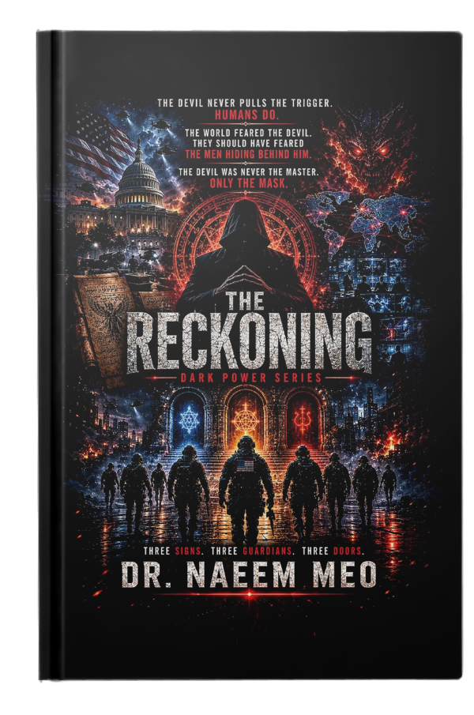
The Reckoning
A supernatural AI conspiracy involving the JINN Network, ancient knowledge, manipulation of human vulnerability and a battle between technology and dark forces.
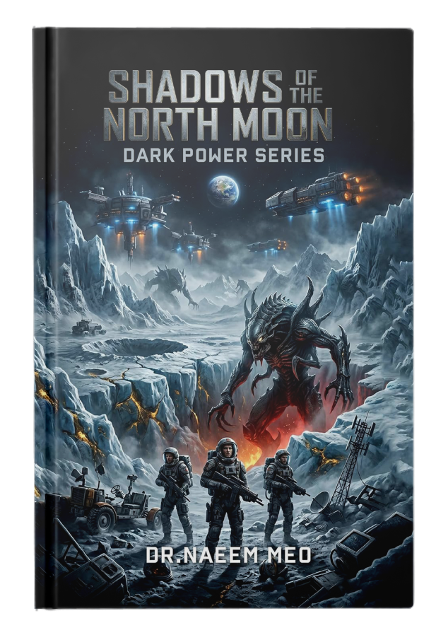
Shadows of the North Moon
A military science-fiction thriller about a secret lunar resource race, engineered forces, rival powers and alien entities that change the mission from profit to survival.

DR. NAEEM MEO • MEDIA & PRESS KIT 5

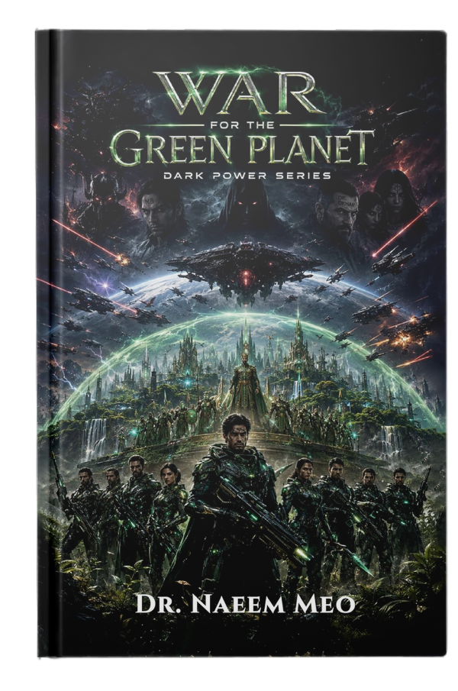
War for the Green Planet
A space-war thriller in which Aadil and his team help an alien civilization resist the North Moon Shadows while confronting a wider alliance of corruption, technology and supernatural power.

DR. NAEEM MEO • MEDIA & PRESS KIT 6

POWERPLAY SERIES

Healthcare, technology, crime and institutional power.

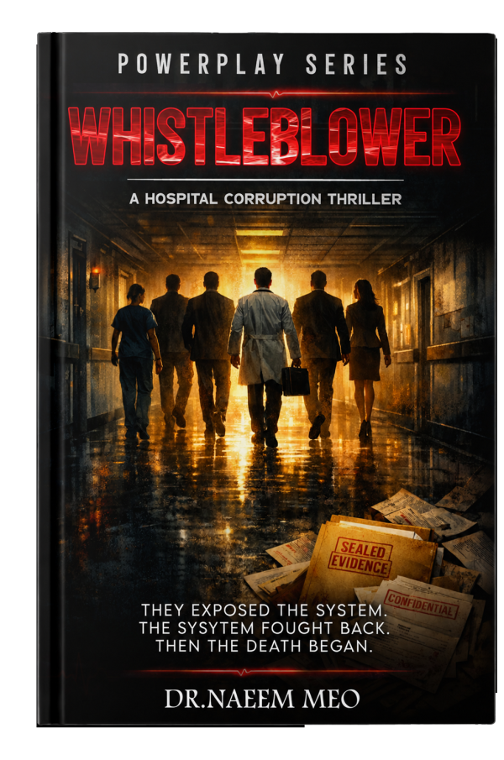
Whistleblower
A healthcare thriller about a family and insiders uncovering unnecessary procedures, financial incentives and an institution determined to protect itself.
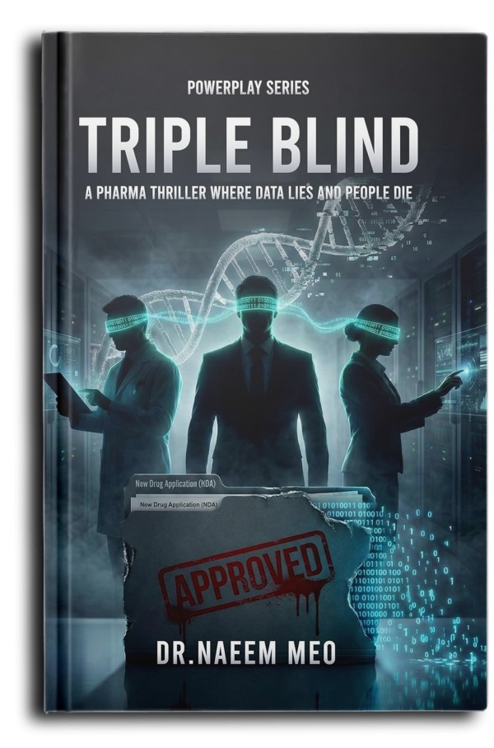
Triple Blind
A techno-thriller about AI, drug development and regulatory manipulation, as a scientist uncovers allegedly engineered clinical data and risks everything to expose it.

DR. NAEEM MEO • MEDIA & PRESS KIT 7

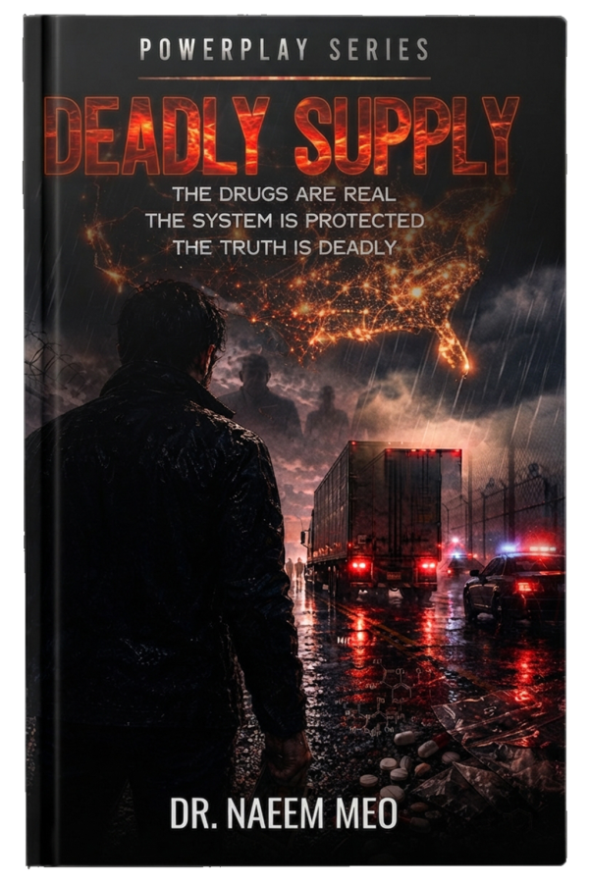
Deadly Supply
A crime thriller following a father and investigators as they trace an overdose death into a wider network of illegal drug distribution and hidden power.

DR. NAEEM MEO • MEDIA & PRESS KIT 8

DEAD MAN’S DISCLOSURE SERIES

Secrets, political intrigue, science fiction and inherited memory.
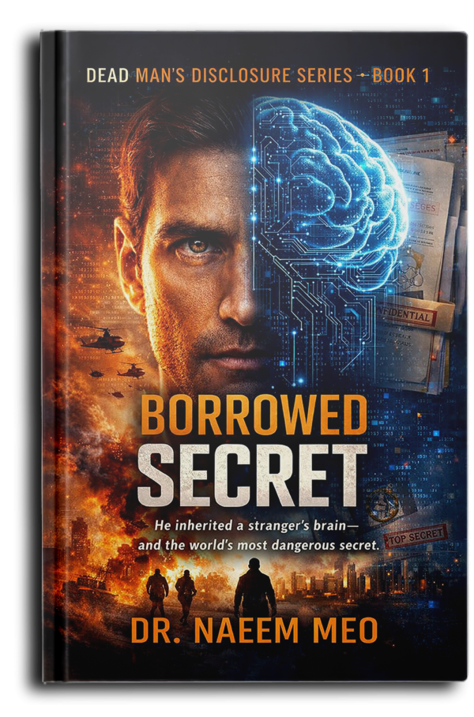
Borrowed Secret
An investigative journalist dies after uncovering a major arms deal. After a classified brain-transplant procedure, another man inherits his memories and follows the secrets they contain.

DR. NAEEM MEO • MEDIA & PRESS KIT 9

THE SHADOWS OF STATE SERIES

Love, disappearance, secrecy and political intrigue.

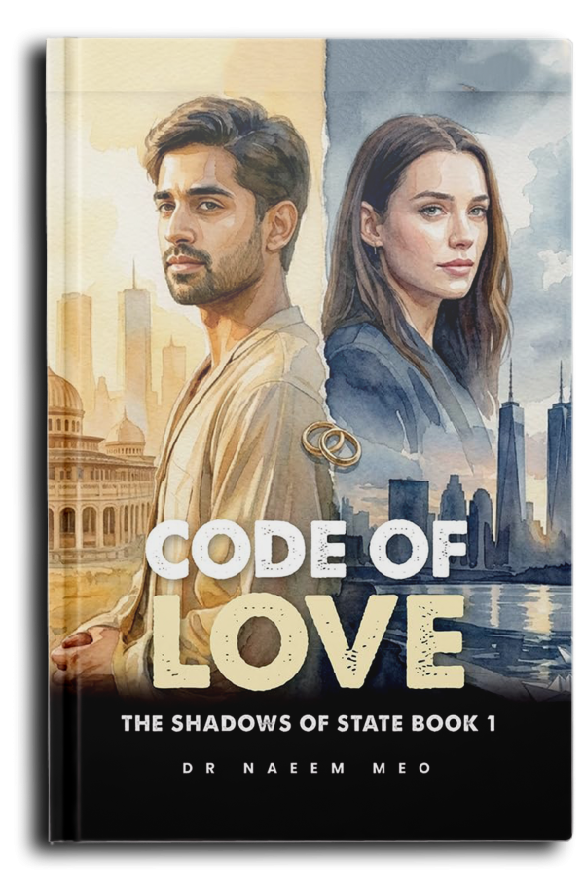
Code of Love
Aadil saves the U.S. Ambassador’s daughter in Pakistan and falls in love with her. After his disappearance on 9/11, she discovers information suggesting his story did not end there.
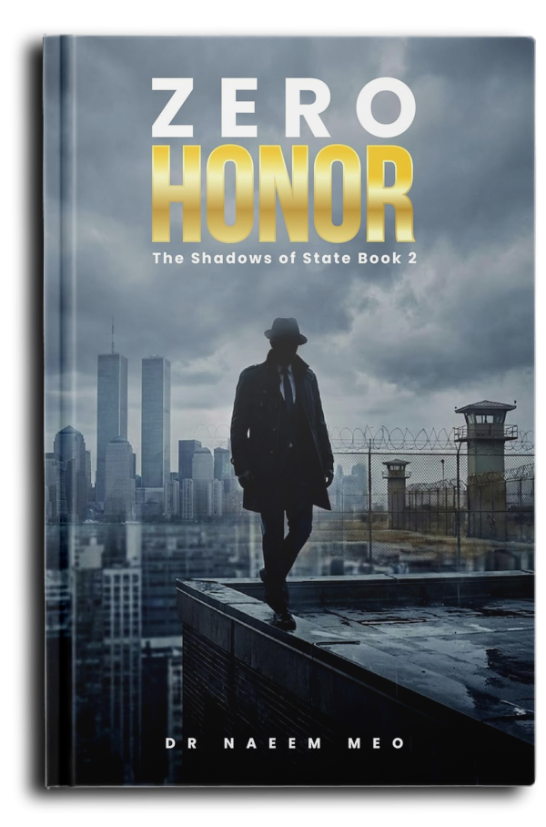
Zero Honor
Ashley learns that Aadil survived 9/11 and is imprisoned at Guantanamo Bay, leading her into a dangerous legal and political fight against secrecy and power.

DR. NAEEM MEO • MEDIA & PRESS KIT 10

CONSPIRACY

Conspiracy, justice and institutional power.

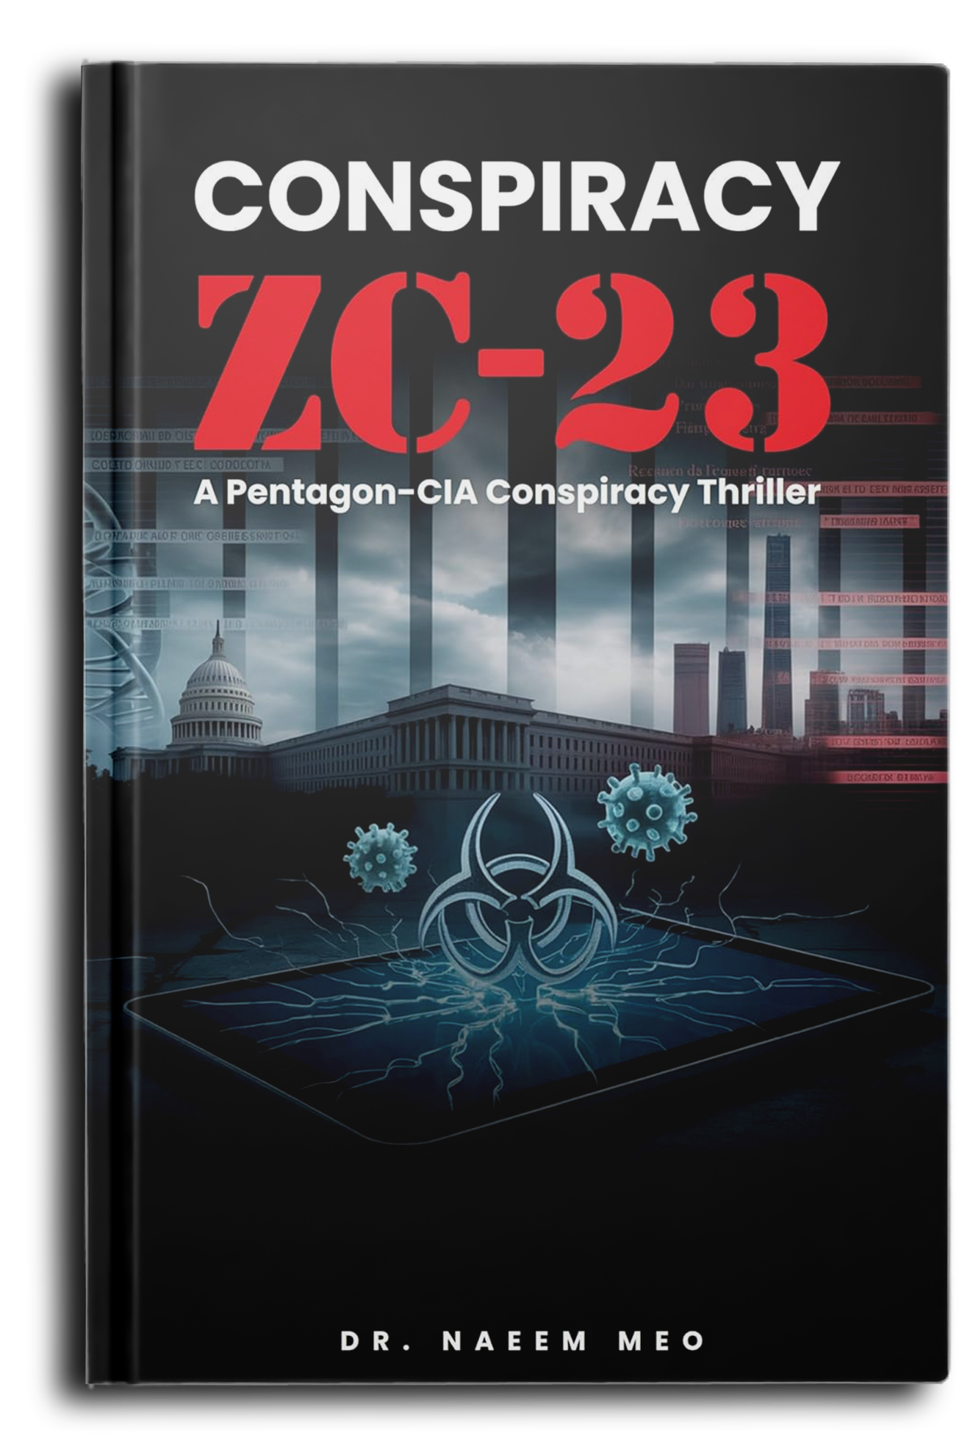
Conspiracy ZC-23
A mysterious prison outbreak leads to a bioterrorism conspiracy involving a biomedical company, government officials, a weaponized virus and a race to expose the truth.
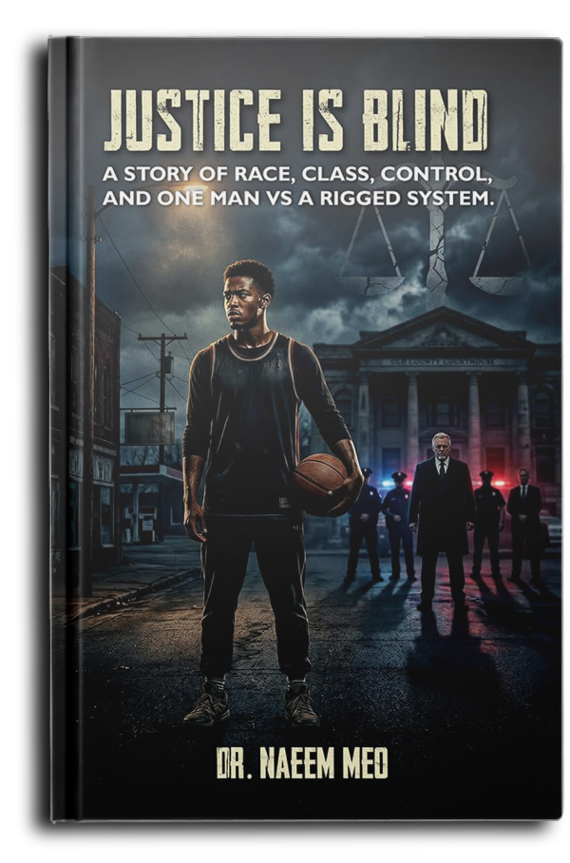
Justice Is Blind
A gifted young basketball player is framed by a powerful family using political connections and the justice system, forcing him to fight a system designed to destroy his future.

DR. NAEEM MEO • MEDIA & PRESS KIT 11

AUTHOR BRAND

The questions behind the stories.
WHERE FICTION CHALLENGES POWER. QUESTION EVERYTHING.
TRUST NO ONE.
FOLLOW THE EVIDENCE.
SOURCE NOTE
All book descriptions in this edition are condensed from the supplied author document. Titles and series have been kept separate so that each description remains attached to the correct book. No additional plot details have been invented for titles not described in the supplied material.

DR. NAEEM MEO • MEDIA & PRESS KIT 12

